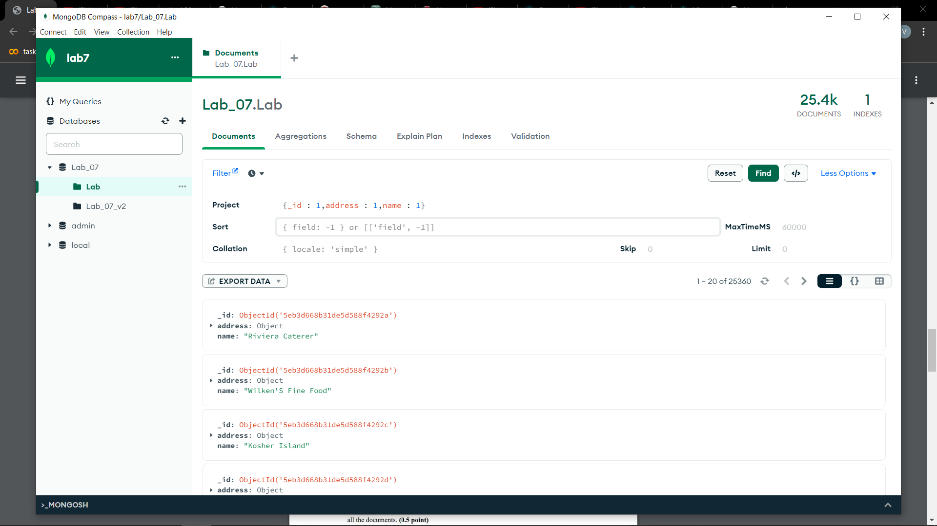

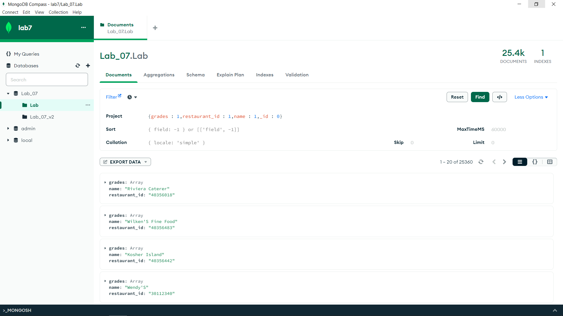

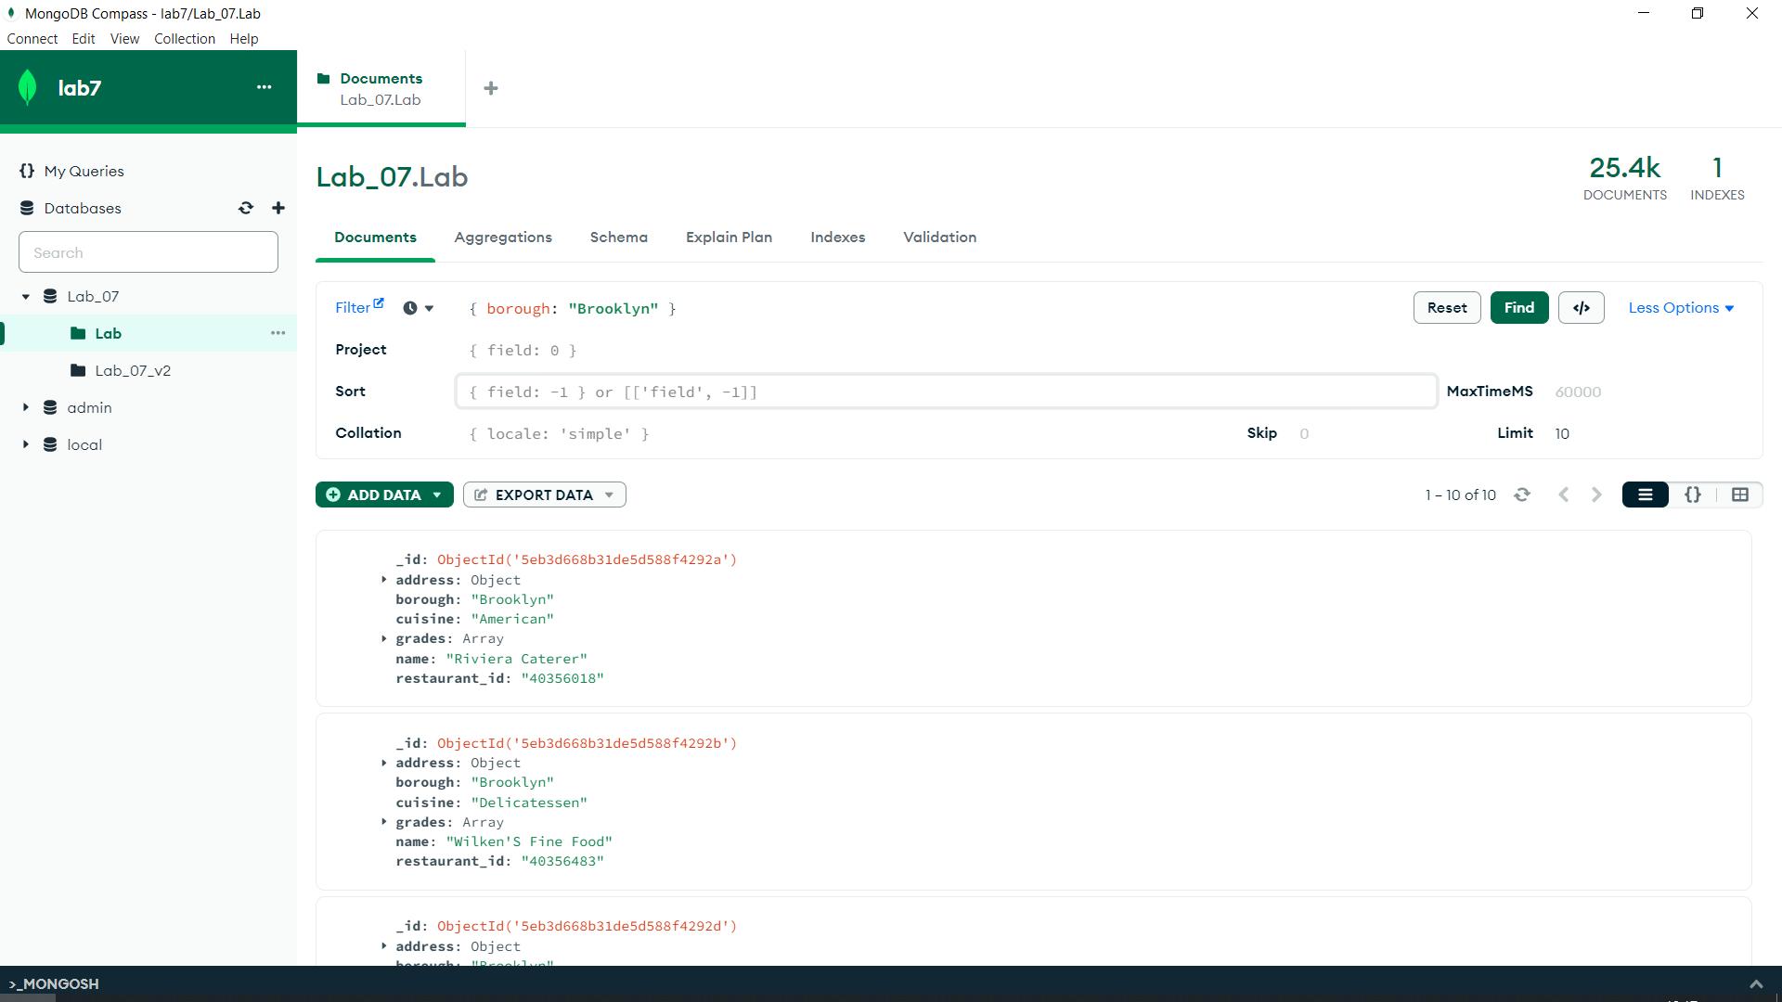

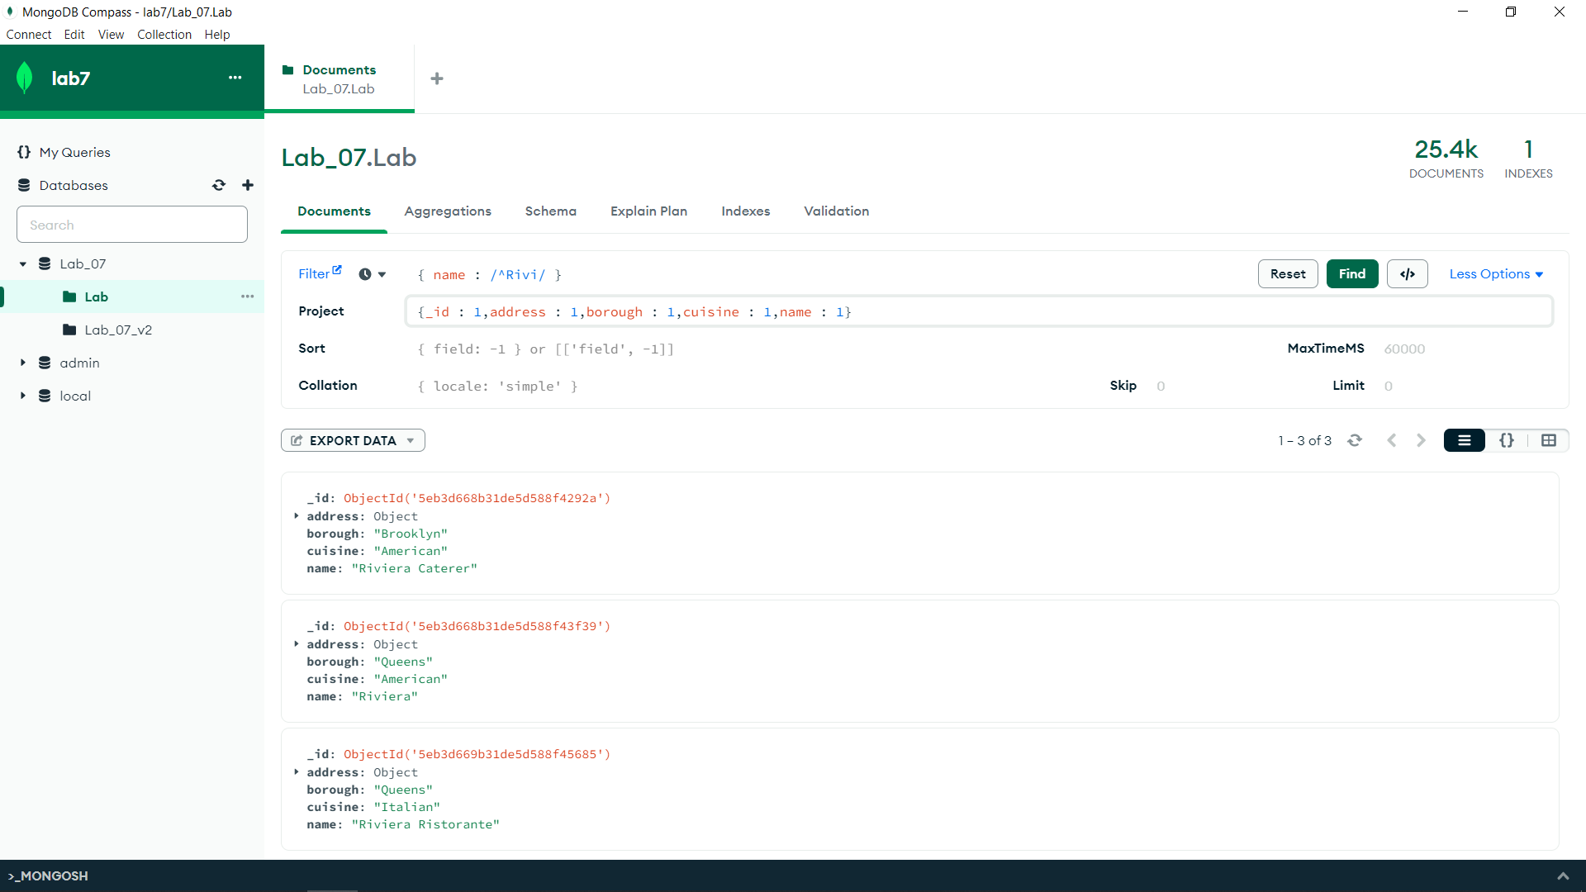

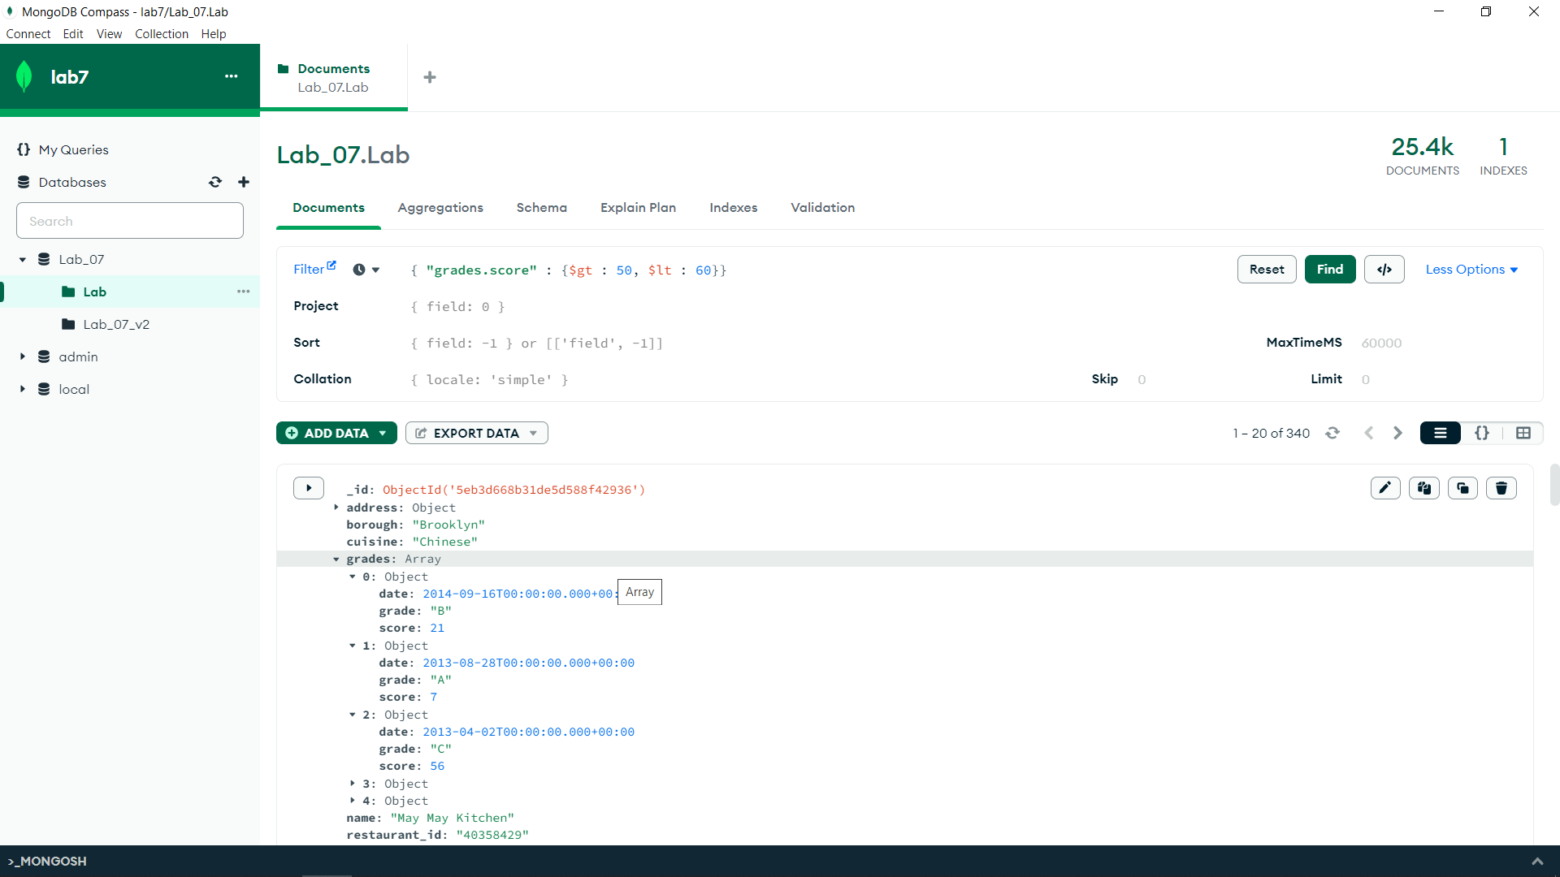

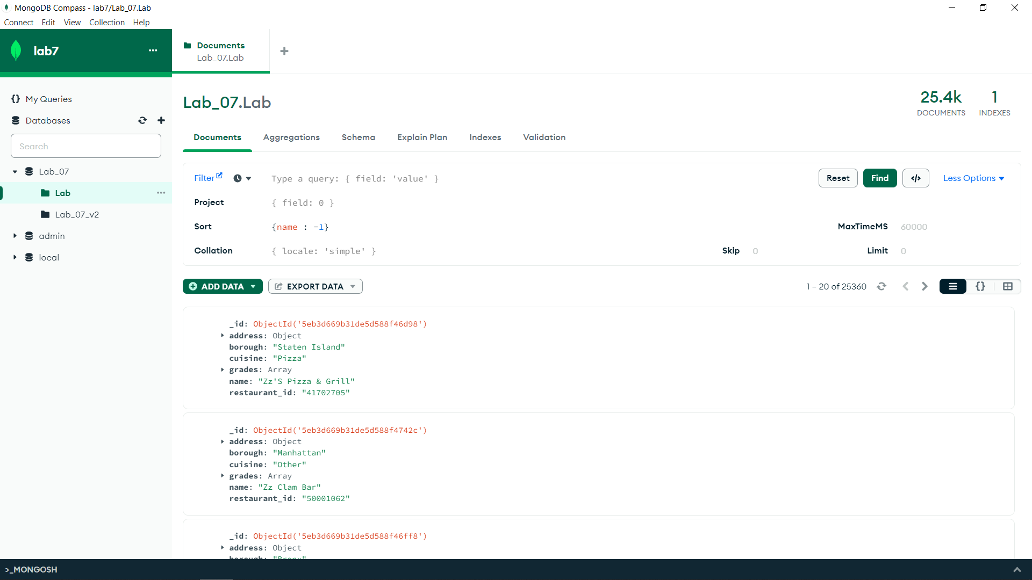

db.Lab.aggregate([{

$unwind: "$grades"

},

{

$group: {

_id: "$_id",

highest_score: {

$max: "$grades.score"

}

}

}

])

